Zichong Wang

Dr. Wenbing Zhang

6/16/2022

Lab Report

1. Test accuracy: 58.88%

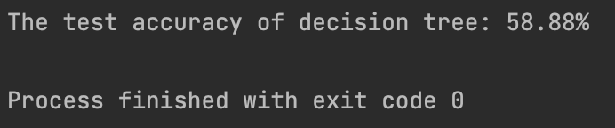

The whole project has 6 functions.

cal_entropy: calculate the entropy

split_dataset: Based on the best choice, split the dataset.

choose_best_to_split: Based on the FIG choice the best position.

vote_label: Based on the most occur feature to choice

decesion_tree: Build the decision tree.

accuracy_test: Calculate the test accuracy

1. Use the dataframe dataset, the dataset is from

https://www.kaggle.com/datasets/johnsmith88/heart-disease-dataset?resource=download